Hype Quick Ai

1.Registration Page

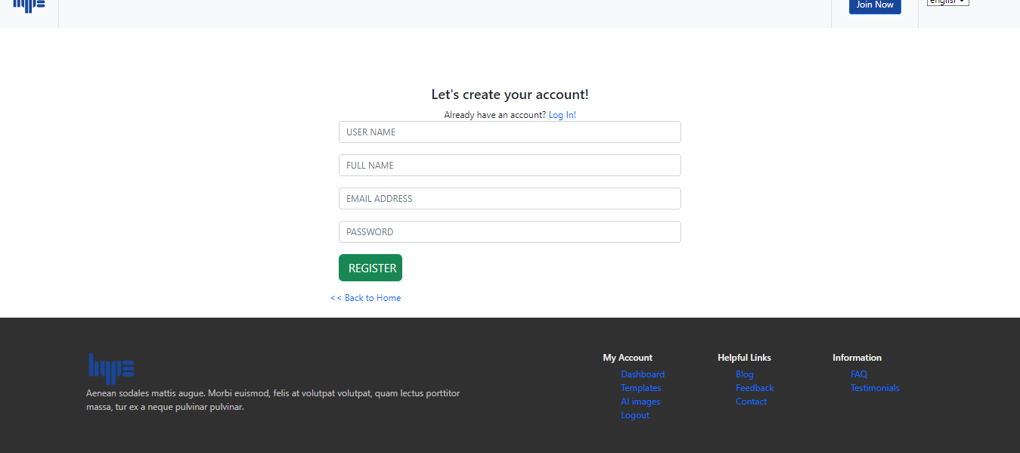

Vedio link: <https://drive.google.com/file/d/1rUi7fdcTZPPnFYz528CNpmngzViEyo48/view?usp=drive_link>

2.login page

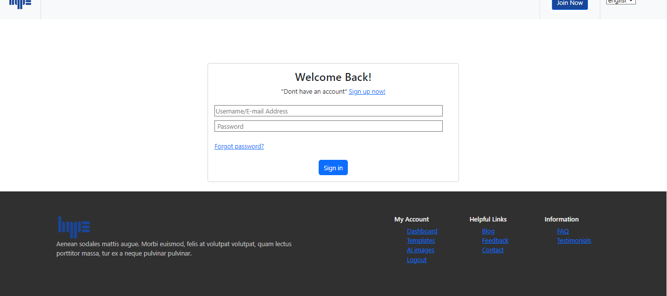

Vedio link:

<https://drive.google.com/file/d/18nlUEwCO4MYSCXw4l4k1wgBiSwqbNbbZ/view?usp=drive_link>

3.Dashboard page

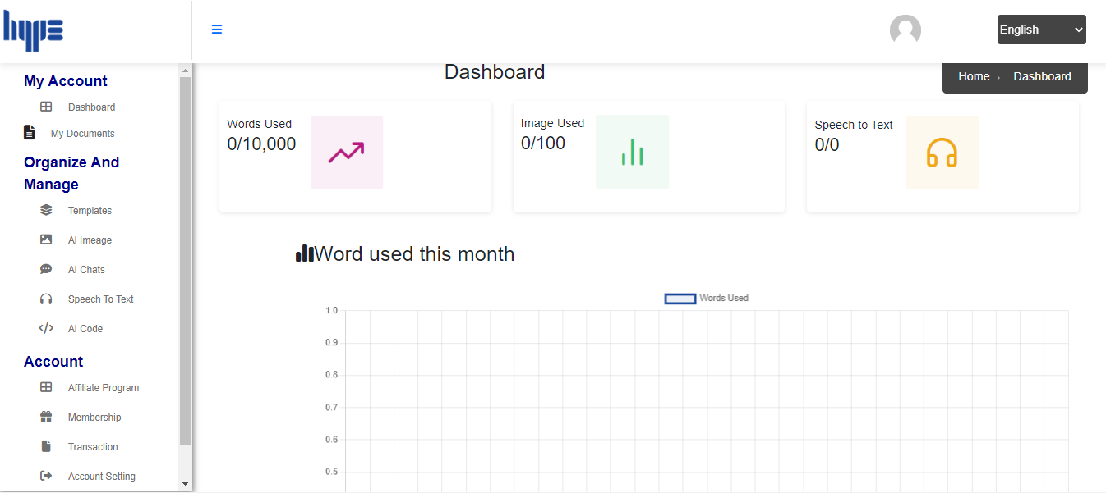

Vedio link:

<https://drive.google.com/file/d/1BuDWlGHeLfppFe1VKt1tH5p286-JNcZJ/view?usp=drive_link>

4.All Document page

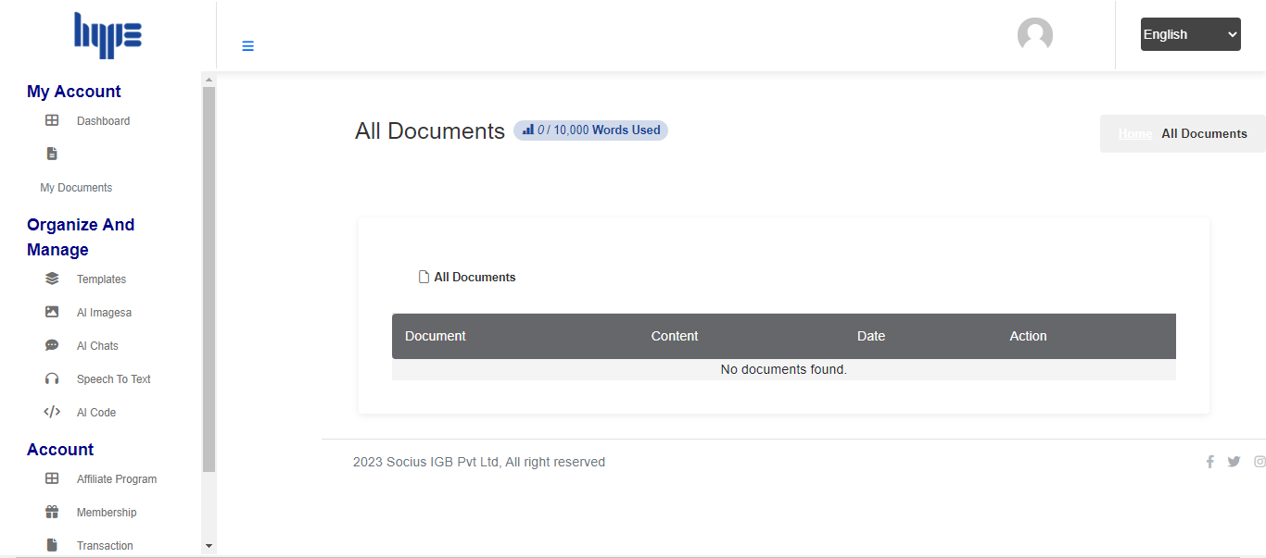

Vedio link: <https://drive.google.com/file/d/1M5HVe2EhEI4Gw2qcLprt_o9rISrgKJqi/view?usp=drive_link>

5.All Ai Images

